**Experiment No 8**

**Aim:**

To design creative content using Canva for promoting the console rental and game account access business on social media platforms.

**Software Requirements:**

* **Canva** (for designing promotional content)
* **Internet Browser** (for accessing Canva)
* **Social Media Platforms** (Facebook, Instagram, Twitter, etc., for publishing)
* **Graphics & Stock Images** (for designing visuals)
* **Creative Copywriting Tool** (optional, for generating ad copies)

**Theory:**

In the digital era, social media marketing plays a crucial role in brand promotion. Using visual-based platforms like **Instagram, Facebook, and Twitter**, businesses can effectively engage with their target audience. **Canva** is an easy-to-use graphic design tool that allows businesses to create eye-catching promotional materials. By leveraging templates, fonts, and multimedia elements, businesses can craft high-quality content without requiring advanced design skills.

For a **console rental and game account access service**, engaging content such as posters, carousels, and short promotional videos can boost customer interest and conversions.

**Key Elements of Social Media Promotion Using Canva:**

1. **Branding** – Consistent use of colors, fonts, and logos.
2. **Call-to-Action (CTA)** – Encouraging users to rent consoles or sign up for game access.
3. **Engagement-Driven Content** – Polls, interactive Q&A, and gameplay snippets.
4. **Targeted Ad Creatives** – Designed to attract gamers looking for flexible access to gaming.

**Steps:**

**1. Setting Up Canva**

* Log in to Canva (or create an account).
* Select a suitable **social media template** (Instagram post, Facebook ad, Story, etc.).

**2. Designing the Promotional Content**

* Choose a **theme** and a **color scheme** that aligns with gaming aesthetics.
* Add **high-quality images** of consoles and popular games.
* Insert **catchy taglines** (e.g., “Game Without Limits – Rent & Play!”).
* Use **iconography** related to gaming (controllers, joysticks, action buttons).
* Highlight your **service benefits** (affordable, flexible, no long-term commitment).

**3. Adding Call-to-Action (CTA)**

* Examples:
  + **“Sign Up Now & Start Playing Instantly!”**
  + **“Rent. Play. Repeat. Click the link to book your console today!”**
  + **“Why buy when you can rent? Explore our gaming plans now!”**

**4. Optimizing for Social Media Platforms**

* Resize designs for different platforms (Instagram, Facebook, Twitter).
* Create a **carousel post** to explain the service in multiple slides.
* Design **Instagram/Facebook Stories** with motion effects.

**5. Exporting and Publishing**

* Download the content in **high-resolution PNG or MP4 (for animations).**
* Post on social media with relevant hashtags (e.g., #GameOnRent #PlayWithoutLimits #GamingMadeEasy).
* Monitor engagement and refine content based on audience response.

**Output:**

* Professionally designed promotional content for social media.
* Engaging posts that attract potential customers.
* Increased awareness and interest in the gaming rental service.

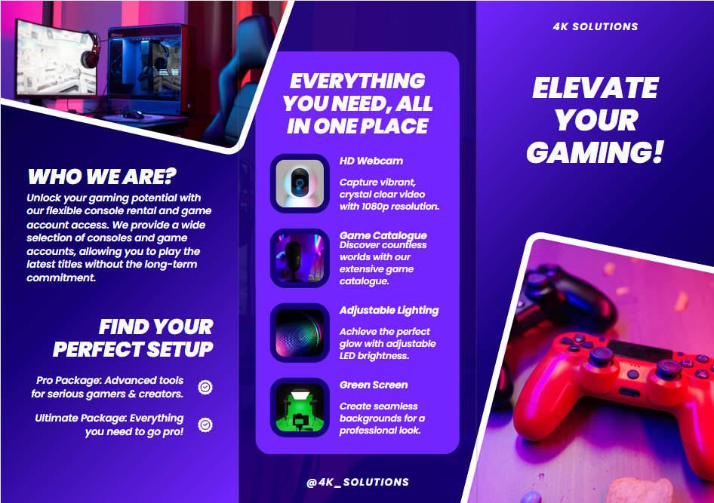

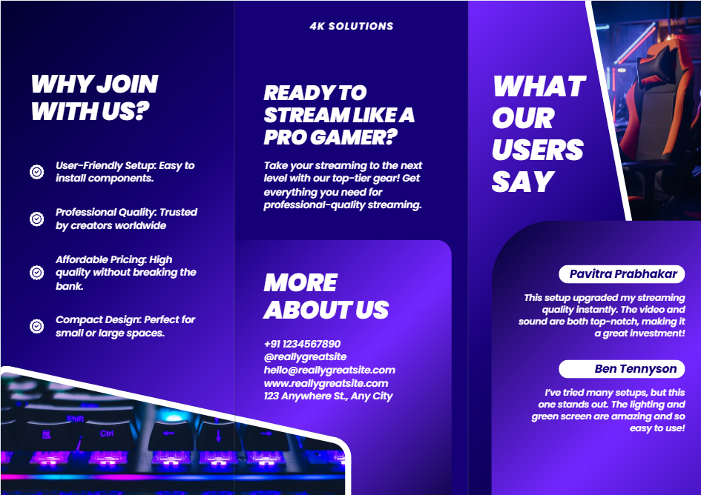

**Conclusion**

By using Canva, creative and compelling promotional content can be designed effortlessly. The content enhances brand visibility and attracts gaming enthusiasts who seek flexible console rental and game account access. A strategic approach to social media marketing ensures higher engagement and customer conversions.